COMP2020 TECHNOLOGIES FOR WEB APPLICATIONS


SCC T2, 2022: Major project (30%)

MedBook Data Dictionary

The MedBook database consists of 3 tables. Structure of each table is described below. A description of how to connect to the database is given at the end of this document.

Table 1: patient
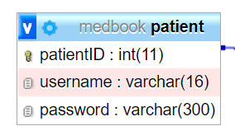

Table 2: clinic
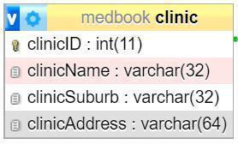

Table 3: bookingList (for registered patient’s bookings)

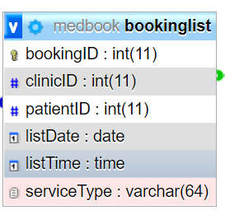

Relationship for the MedBook database

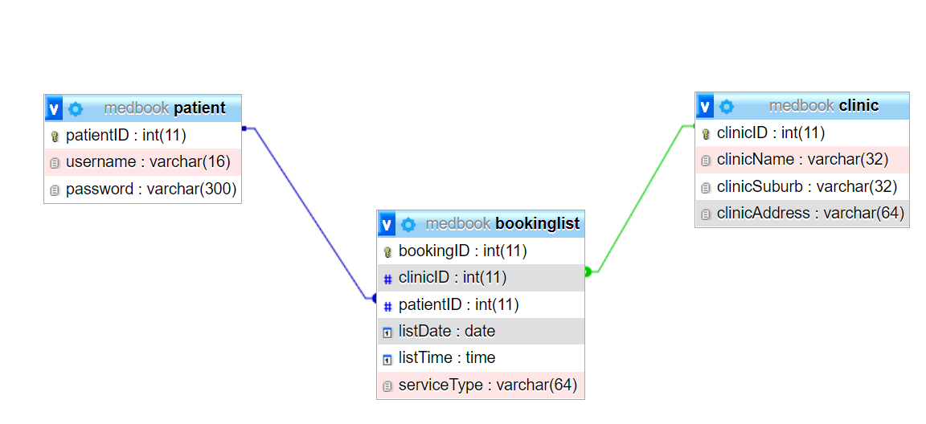

Connecting to the MedBook Database

To connect to the MedBook database, use

<?php
include(‘conn.php’);
?>

conn.php script is included in the specification folder.

Note

Use the supplied medbook.sql to create and populate the tables in the MySQL on the XAMPP. The bookinglist is initially empty because we have not recorded any bookings from registered patients. Use the supplied allTables.php script to view the data (make sure you use the connection information as indicated above).

